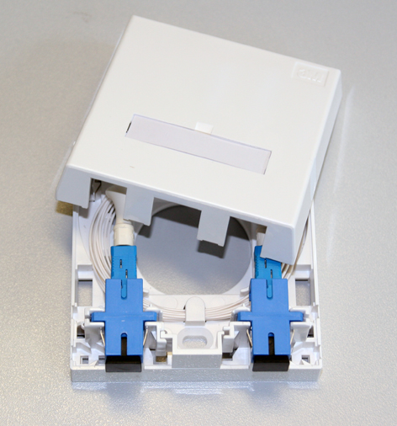
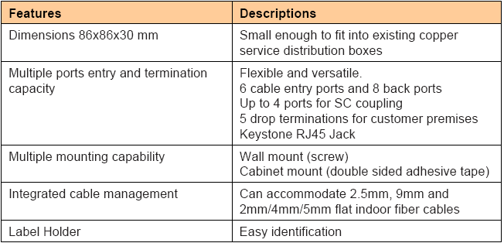
BTO (86x86)
Indoor/Residential
Dimensions (mm)
WideHeight Depth
868686
Wall Boxes (termination/distribution)

