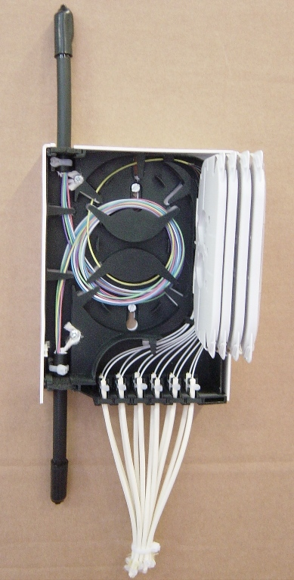
PBPO (PBO 6-12)
Indoor
Dimensions (mm)
WideHeight Depth
16021060
Interface between optical access network and end customer building

Features;
Up to 12 splices
Up to 12 SC connectors
Compact size 160x210x60mm
Indoor , wall mount only.
Wall Boxes (termination/distribution)

