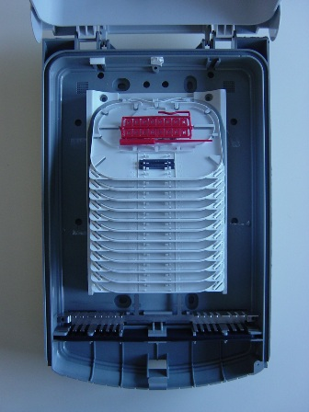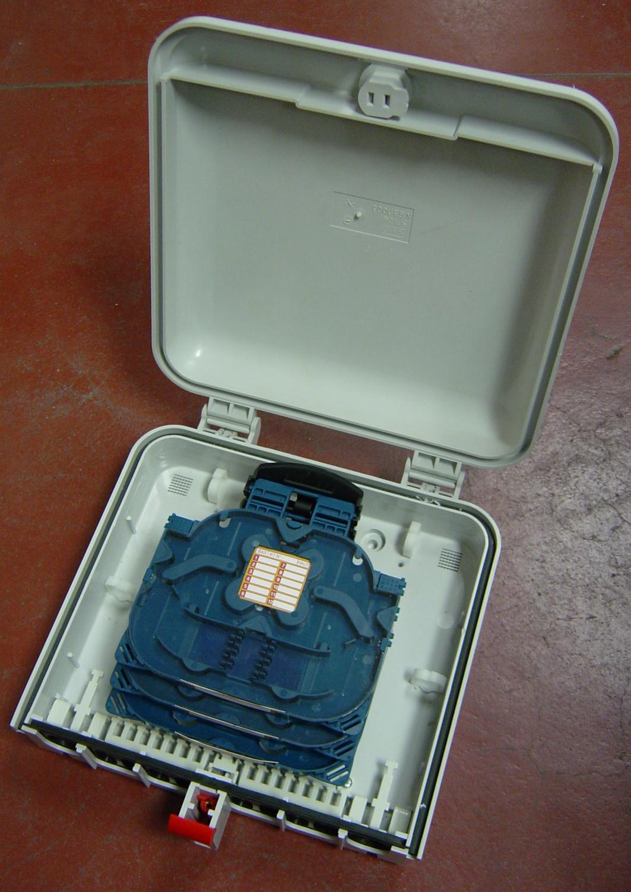
2 different versions
IP55
Possibility of using fusion or Fibrlok splicing
Optional key locking !
PBO T1
PBO T2
Outdoor
Dimensions (mm)
WideHeight Depth
24027080
Dimensions (mm)
WideHeight Depth
25540085
Wall Boxes (termination/distribution)

