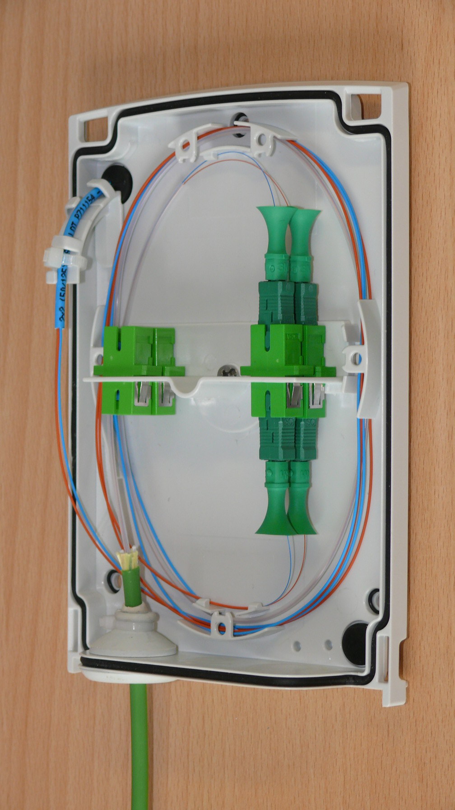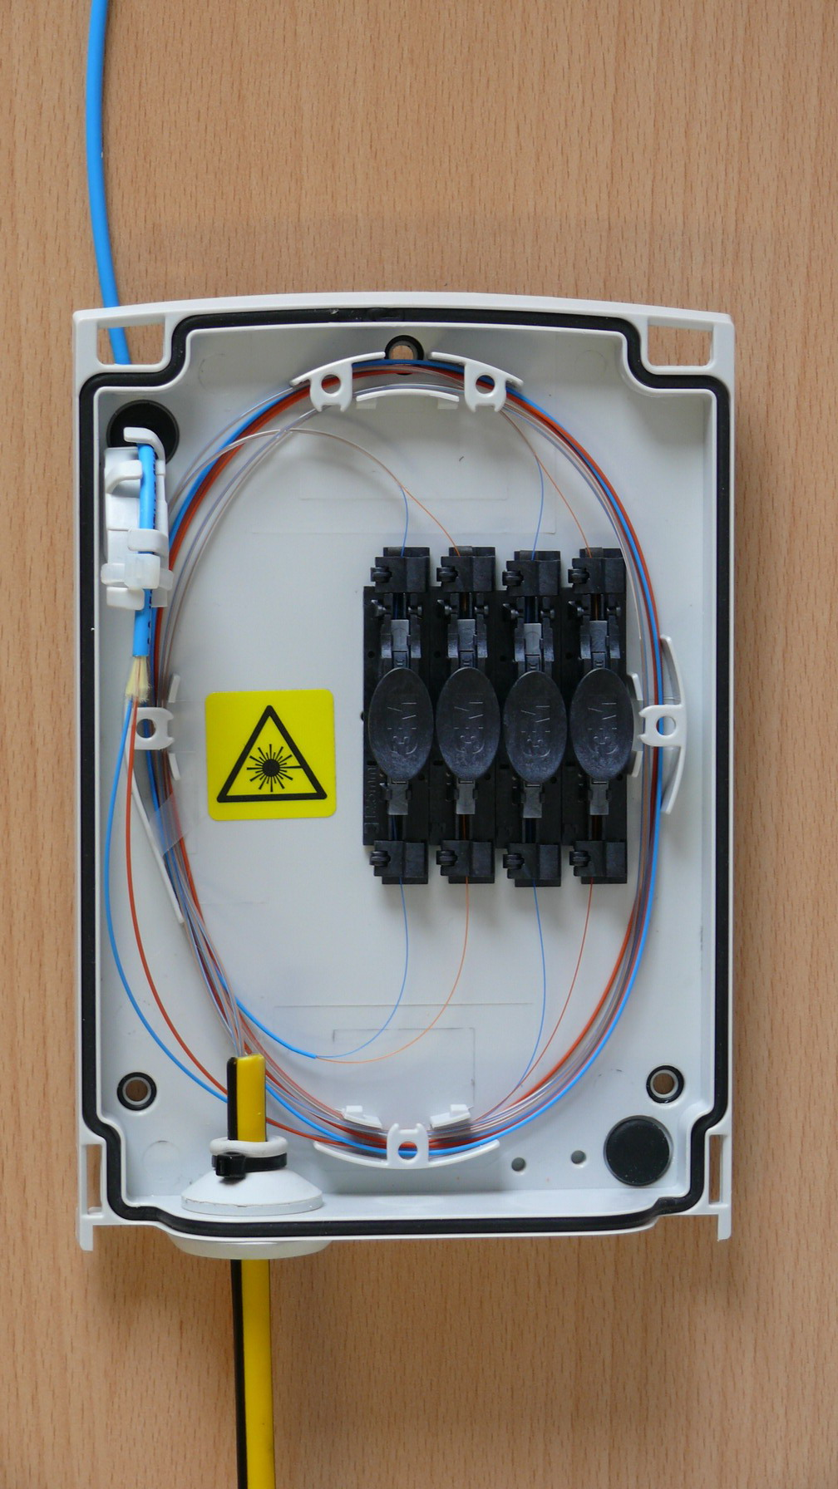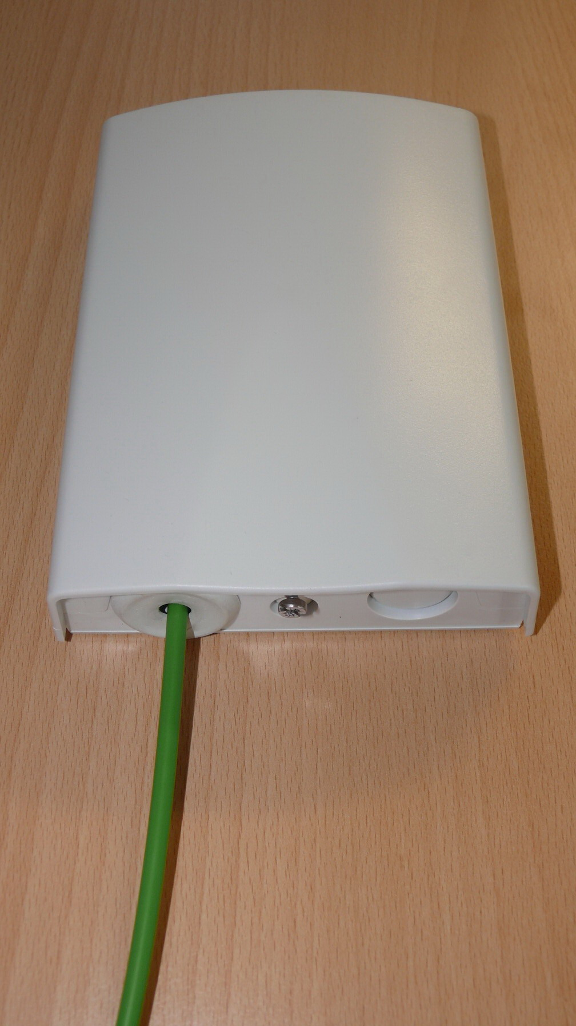
Outdoor/indoor distribution box,
IP54 protection level,
compatible to Blown Fiber applications,
up to 4 fibers terminated with NPC or Fibrlok.
Outdoor/indoor
Interface network

CTB - FTB
Wall Boxes (termination/distribution)

