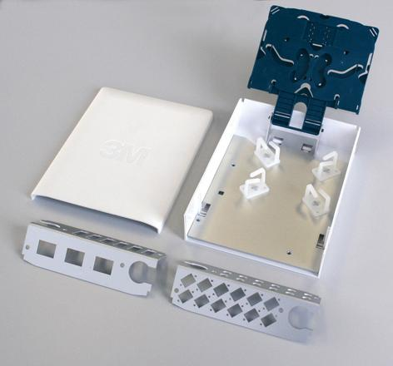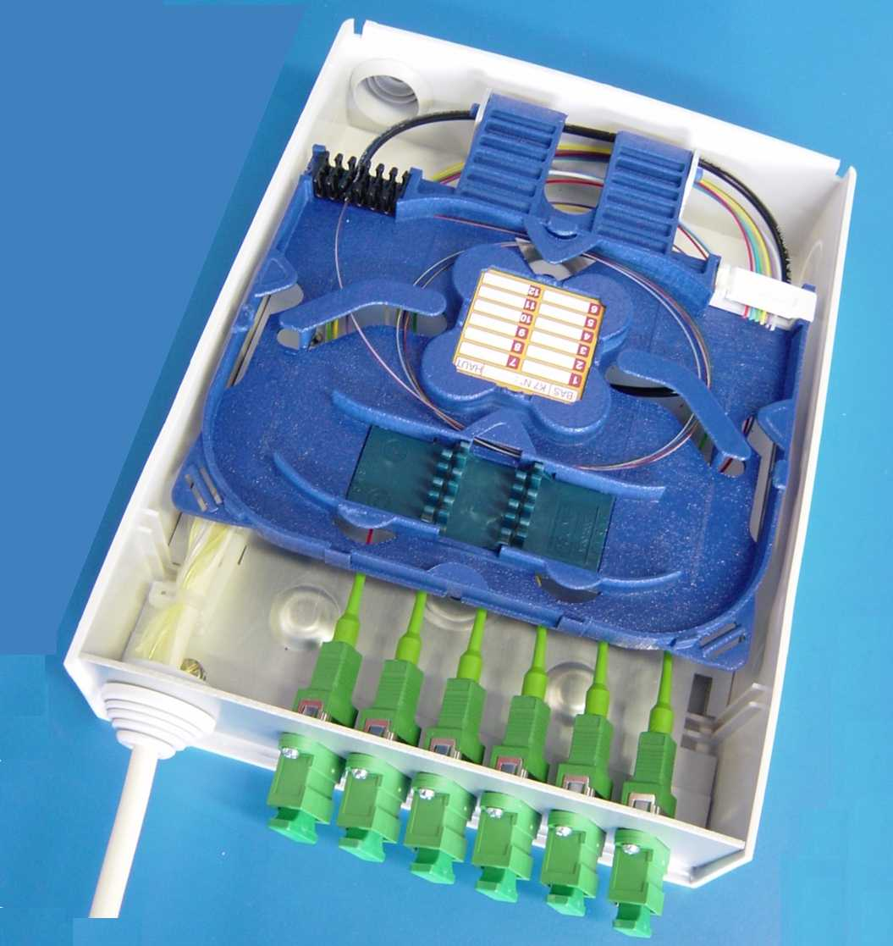
Branch-off to residential premises

Indoor distribution Box
Connection via pigtails
IP31 protection
Cassette for fibre management
Compatible to 12ea SC, ST, FC, SC duplex and VF45

BDI
Indoor
Dimensions (mm)
WideHeight Depth
16021060
Wall Boxes (termination/distribution)

