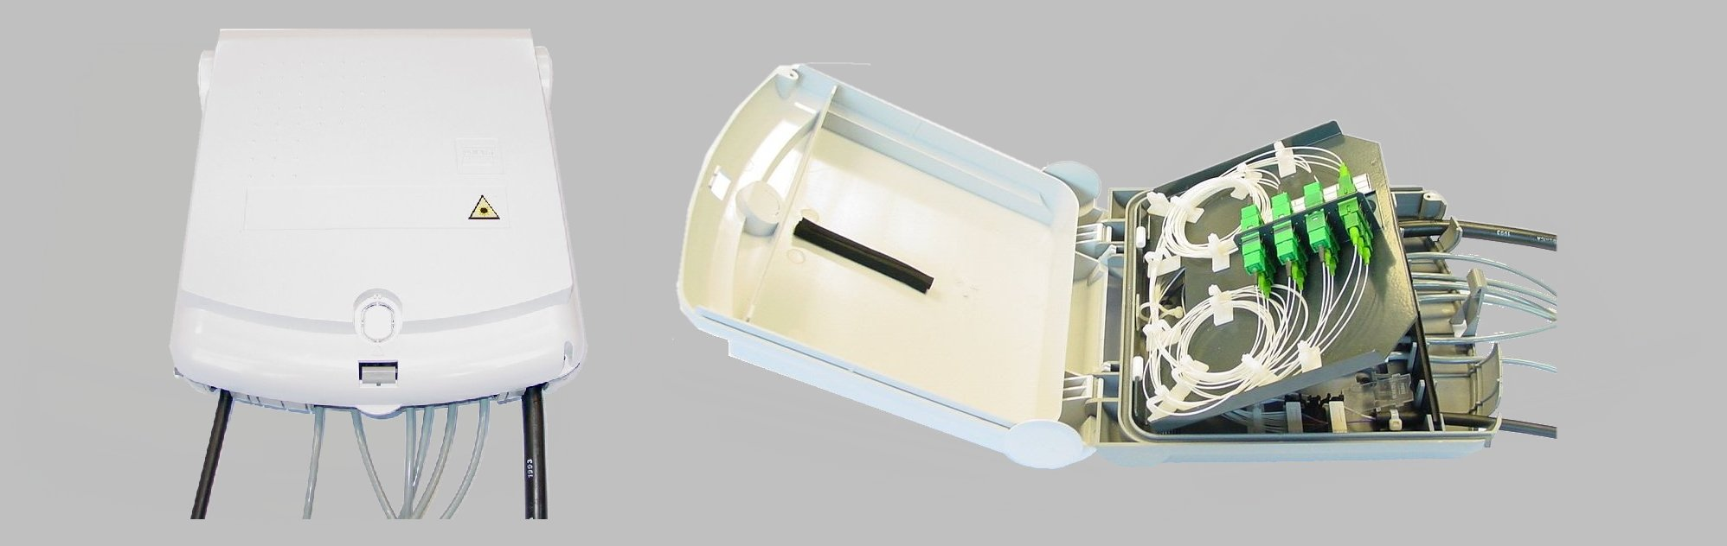

Last point distribution for FTTH network.
Up to 12 or 24 optical fiber splices.
With IP55 protection; suitable for outdoor installation.
Equipped with a splice tray, coupling plate.
Flexible construction; variety of different coupling/pigtail combinations.
Outdoor
Interface network
BA Boxes
Dimensions (mm) BA6
WideHeight Depth
25529286
Dimensions (mm) BA12
WideHeight Depth
25540086
Wall Boxes (termination/distribution)

