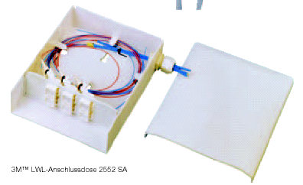
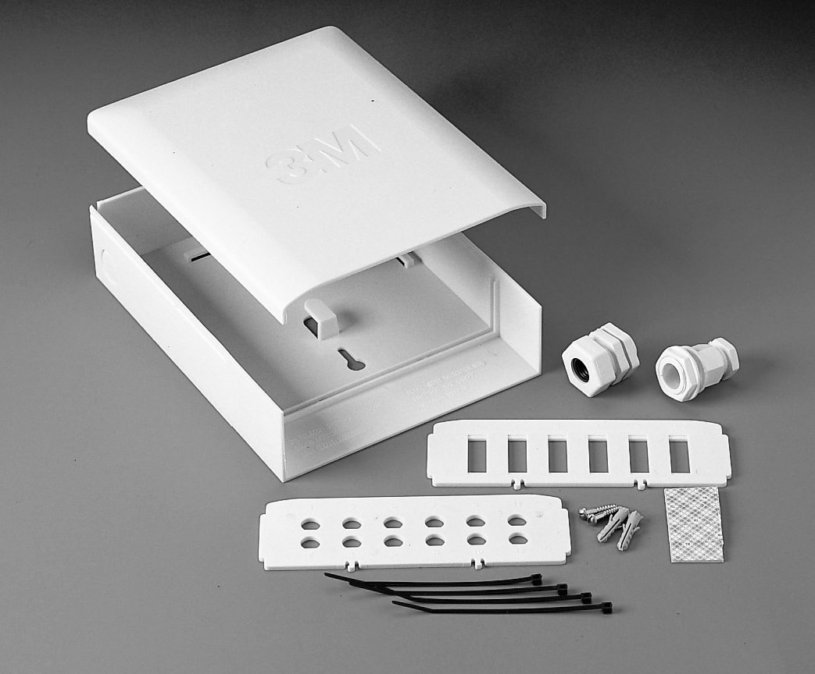
Indoor Distribution 2552 SA

Cost effective
Direct Termination
Compatible with 12 ST, FC et 6 SC Duplex
And VF-45
Indoor
Dimensions (mm)
WideHeight Depth
16021060
Wall Boxes (termination/distribution)

Cena: 445,- Kč obj.č. UE-9999-7838-5

